University of New York Tirana

Distributed Systems

Student: Rea Lamaj

Coursework Title: Project 1-Development of a distributed object based system based on Remote Method Invocation

**Introduction:**

This project is an implementation of a distributed object-based system with a three-tier architecture based on Remote Method Invocation.

**Project Implementation:**

In the first tier, there is a client program that sends requests to the server.

In the processing tier, there is a server program that satisfies requests from the clients.

In the database tier, there is a database based on MySQL.

The task is to read from the database and report data back to the client.

The client should send a request to the server through Remote Method Invocation and should then read the response of the server and print it in the console.

The server should receive through RMI the request from the client. It should connect to the third tier and perform a query on the database.

The database is served through the DBMS MySQL Server.

The queries sent by the client are as follows:

1. Number of total products in the database

2. List of all products with their data.

3. List of products with available quantities less than 10 units.

4. Number of total sales

5. Number of total sales over the last month

6. Total amount of sales

7. Total amount of sales over the last month.

**Instructions to run the project:**

* The database tier is found inside the Tier_Server which is the processing tier.
* At Tier_Server, in the Constant java class, the MySQL credentials need to be changed to the credentials at your computer(username and password).
* The database has automatic creation and the insertion of data is in the SQL file found in Tier-Server.

**Images of testing the project:**

I will attach below the screenshots of testing the project and implementing the queries.

**Successful connection to database**

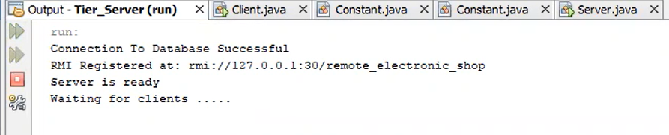

**Running Tier_Client**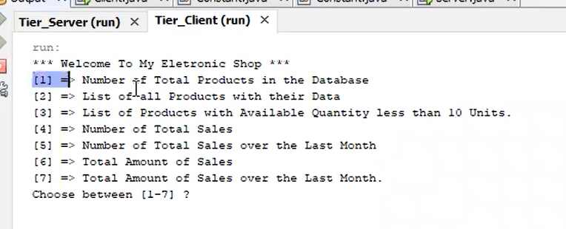

**Query 1. Number of total products in the database**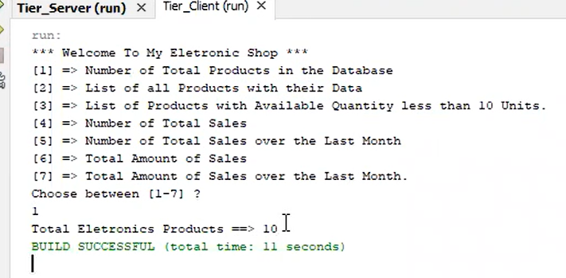

**Query 2. List of all products with their data.**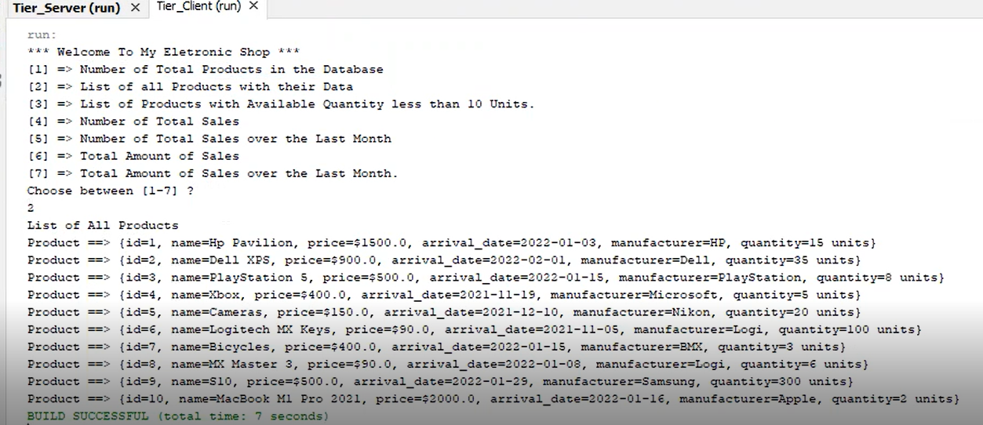

**Query 3. List of products with available quantities less than 10 units.**

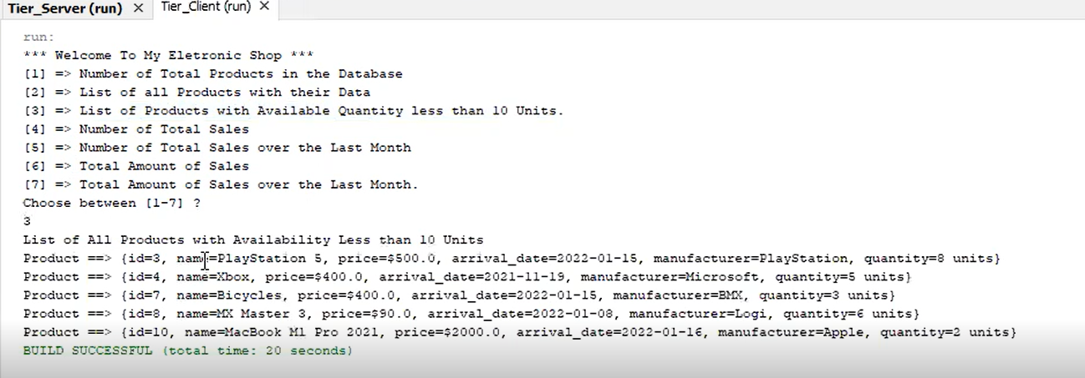

**Query 4. Number of total sales**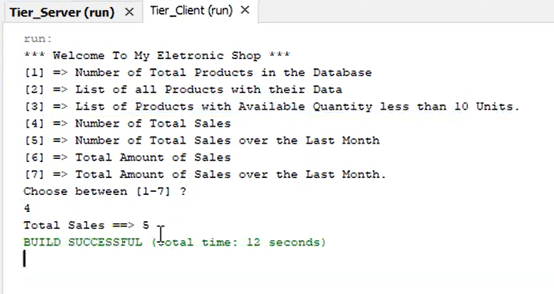

**Query 5. Number of total sales over the last month**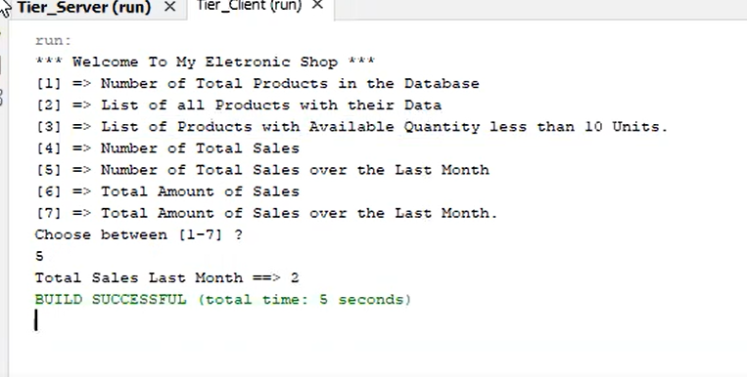

**Query 6. Total amount of sales**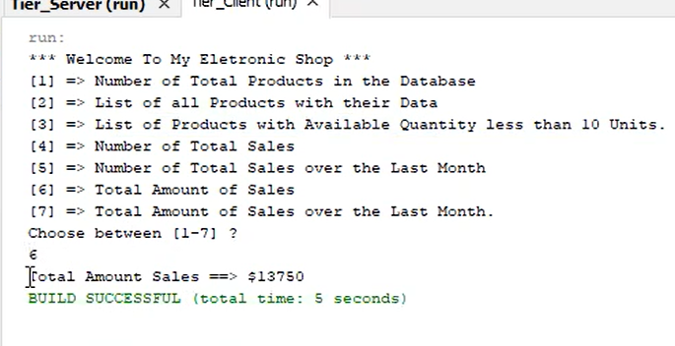

**Query 7. Total amount of sales over the last month.**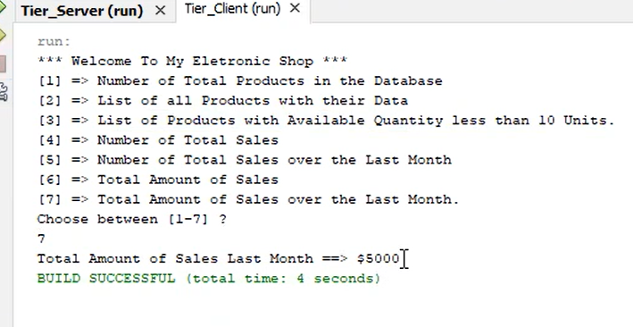

**Database SQL file**